ZONAR CUSTOMER GUIDE
How to Navigate the Versapay Portal
Viewing invoices, making payments, and managing your account, plus frequently asked questions

Getting Started
This guide helps Zonar customers use the Versapay customer portal to view invoices, make payments, review account activity, manage payment information, and keep profile or company information up to date.
If you have not established your Versapay user account, locate the “Welcome to Versapay” email in your inbox. If you cannot find this email, check your spam or junk folder first. If you still cannot find it, contact Zonar Customer Service at customerservice@zonarsystems.com and ask for the invitation to be resent.
If you have already established your account, access the portal at: https://secure.versapay.com
Zonar tip: Watch for legitimate Versapay portal emails from no-reply@versapay.com or acct@zonarsystems.com. Add these addresses to your safe senders list so invoice and portal notifications do not get missed.

Versapay Home Screen
The Home screen provides a summary of your account, including current balance, available credits, recent payment information, and quick access to key portal areas. Use the navigation tabs to move between Invoices, Payments, Orders, and Activities.

Profile and Company Settings
To access your profile settings, click on the down arrow next to your name in the upper right corner of the Versapay window.
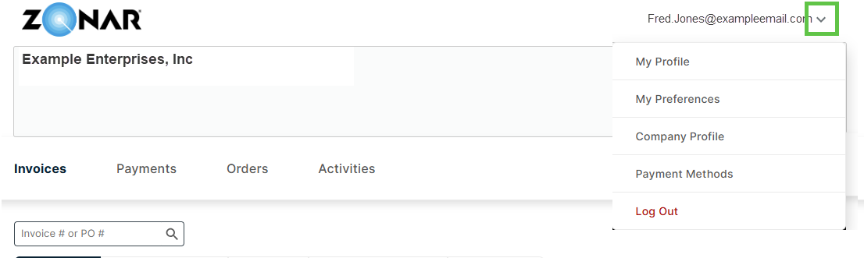
- My Profile: Update your name, password, and security questions.
- My Preferences: Set your preferred language, time zone, and default landing view.
- Company Profile: Review or update company account information where available.
- Payment Methods: Manage saved bank accounts, credit cards, and AutoPay settings.

Managing Payment Methods and AutoPay
- Add or update payment methods: Go to your profile, preferences, or payment settings area to manage saved payment methods.
- Review migrated payment information: If your payment method was migrated, confirm the details look correct before your next payment.
- Set up AutoPay: If AutoPay is available for your account, enable it from the payment settings area and confirm the payment method you want used.
- Credit card note: Credit card payments may include a processing fee. ACH, EFT, or debit card options may be available depending on your account setup.

Invoices
The Invoices section displays current and historical invoices. By default, the view may show open items, but you can filter by status such as open, overdue, all invoices, scheduled payments, or other available options. Use search and filters to narrow the invoice list by invoice number, purchase order, status, or other available criteria.
Click an invoice record to view invoice details, related payments, attachments, comments, and available payment actions.
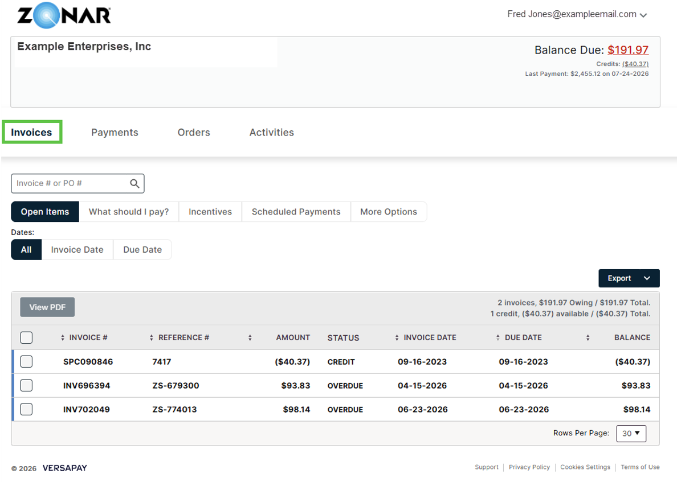

Payments
The Payments section shows payment history for your account. You can review completed payments, see which invoices payments were applied to, and use filters to locate specific payment records. If a payment requires review or was prepaid, available filters can help narrow the list.
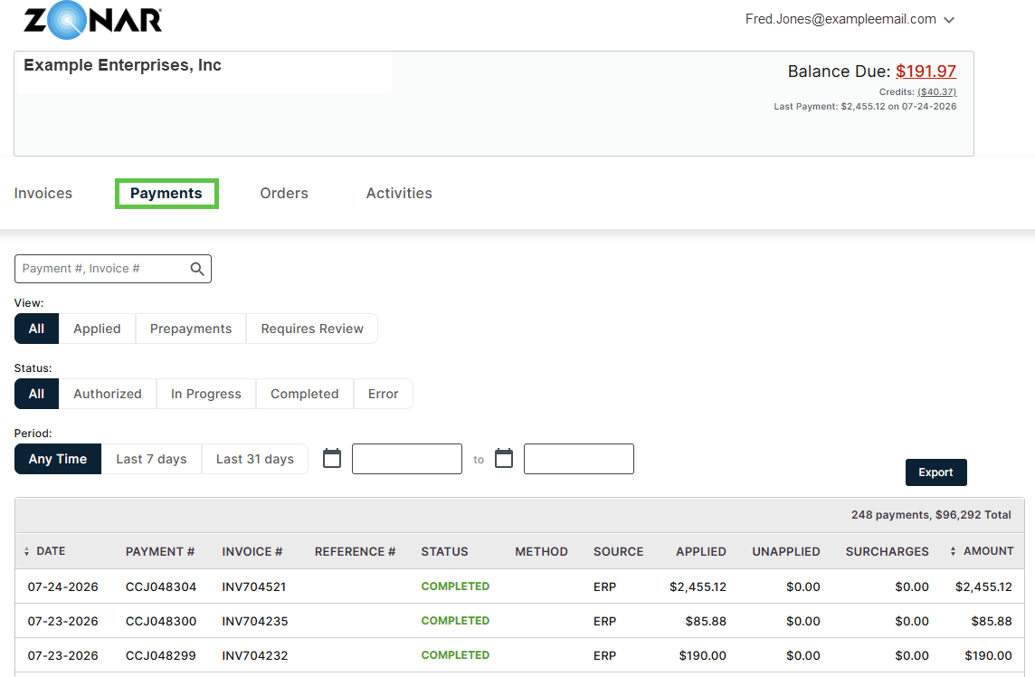

How to Pay an Invoice
- Log in to Versapay. Open the Zonar Versapay portal using your invitation email, invoice notification, or the portal link provided by Zonar.
- Go to Invoices. Select the Invoices tab to view open, overdue, scheduled, or historical invoices.
- Select the invoice or invoices to pay. Use the checkbox next to each invoice, or choose Pay All if you want to pay all outstanding invoices shown in the portal.
- Review invoice details. Click the invoice number from the list if you need to review the invoice, download a copy, view attachments, or confirm related comments before paying.
- Choose Pay or Pay Now. From the invoice list, select Pay after choosing invoices. From an individual invoice, choose Pay Now.
- Select a payment method. Choose an available saved payment method or add a new payment method if needed. Payment options may include bank account, ACH, debit card, or credit card depending on your account setup.
- Review and submit. Confirm the payment amount, payment method, and invoice selection, then complete the payment.
- Save confirmation. After submitting, review the confirmation screen and keep a copy for your records if needed.
- Verify activity. Use the Payments or Activities sections to confirm the payment was recorded and applied to the correct invoice or invoices.

Important: Zonar no longer processes customer payments on your behalf through the prior payment process. Please use Versapay to make or manage payments directly. If you need help accessing your account or finding an invoice, contact Zonar Customer Service at customerservice@zonarsystems.com.

Orders
The Orders section lists open or historical orders associated with your account. If no orders are shown, there may not be any open orders at that time. Use the available status filters or select All to view historical order records.
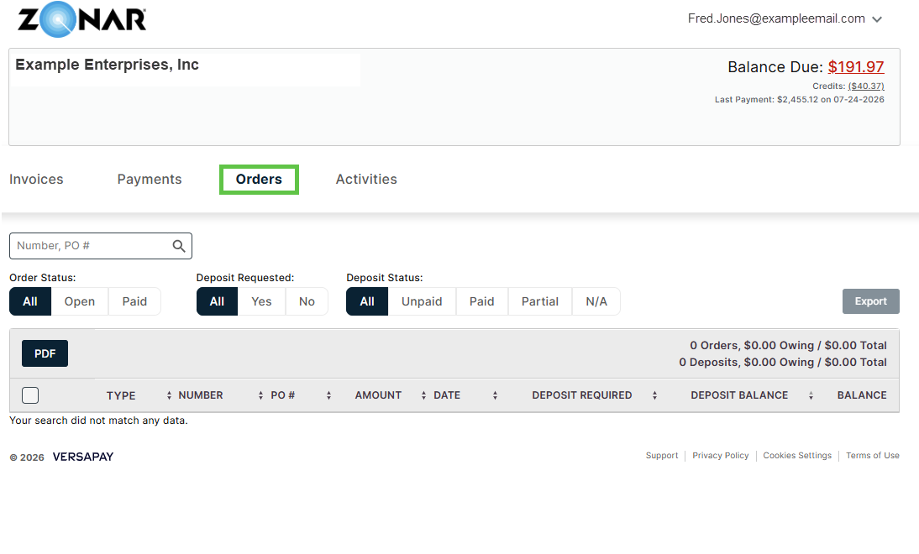

Activities
The Activities section provides a timeline of account activity. This may include invoice publishing, balance updates, payment activity, order updates, or other account-related events. Use this section to understand recent changes or actions that have occurred on your account.
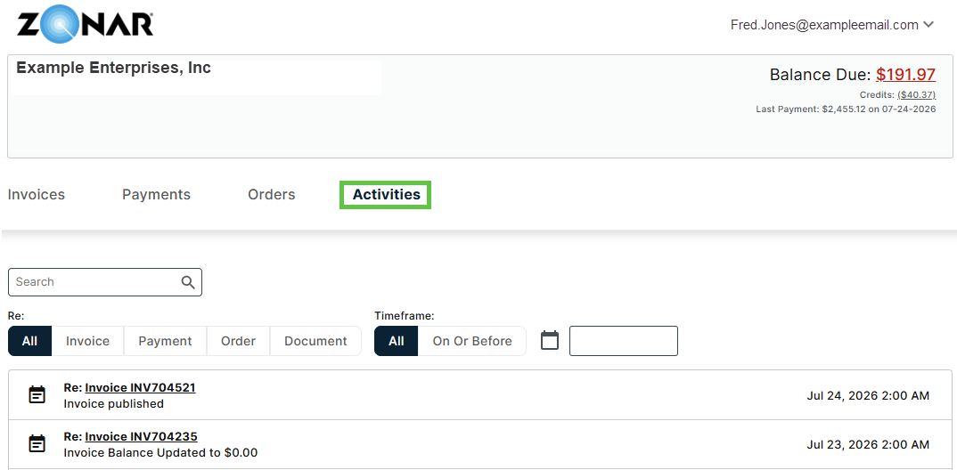

Frequently Asked Questions
When will I receive my Versapay invitation?
You will receive an invitation email from Versapay when your account is ready. Watch for messages from no-reply@versapay.com or acct@zonarsystems.com, and add both addresses to your safe senders list.
What should I do if I do not see my invitation?
Check your spam or junk folder first. If you still cannot find it, contact Zonar Customer Service at customerservice@zonarsystems.com and ask for the invitation to be resent.
Do I need to create a new account?
If you previously made payments via the StaxPay portal, your customer account information has been migrated over. However, you must establish your Versapay user account by following the invitation link, accept Versapay's Terms of Use, and set up your password and profile to gain full access to your Versapay customer account.
Can I still access StaxPay after 8/10?
As of the migration date, StaxPay access will be limited to making payments on open invoices only. All access will be terminated on or about September 30, 2026. All future invoices, payments, and payment method management will be handled in Versapay. Please use Versapay going forward to view invoices and make payments.
Where can I find my invoices?
Go to the Invoices tab to view open, overdue, scheduled, or historical invoices. You can select an invoice to view details, download a copy, review attachments, or make a payment.
Will my existing payment method move to Versapay?
Some existing payment methods may be migrated. Please log in to Versapay and review your payment method before your next payment to confirm the information is accurate.
How does AutoPay work?
If AutoPay is available for your account, you can enable or review it in the payment settings area. If you were previously enrolled in AutoPay, confirm your settings and payment method after logging in.
Where do I confirm a payment was submitted?
Use the Payments tab to review payment history, or check Activities to see recent account updates such as invoice activity, payment activity, or balance changes.
Who should I contact if I need help?
For portal access, invoice, payment, or account questions, contact Zonar Customer Service at customerservice@zonarsystems.com.

Helpful Tips
- Use search and filters when you need to find a specific invoice, payment, or order quickly.
- Click into individual records to view details, download invoice copies, and review related activity.
- Keep your profile, company information, preferences, and payment methods up to date.
- Check Payments or Activities to confirm whether a payment, invoice update, or account change has been recorded.
- If you do not see your Versapay invitation, check your spam folder and confirm no-reply@versapay.com and acct@zonarsystems.com are listed as safe senders.
- For help, contact Zonar Customer Service at customerservice@zonarsystems.com.

